**HTML Task to know usage of basic tags.**

1. Fix the bugs in below snippet

<html lang="en">

<head>

<title>Document

<body>

guvi

</title>

</head>

<div>

Lorem ipsum dolor sit amet consectetur adipisicing elit.

<div>

<div>

Guvi Geek Network

</div>

</body>

</html>

**Ans:**

**<html lang="en">**

**<head>**

**<title>Document**

**guvi**

**</title>**

**</head>**

**<body>**

**<div>**

**Lorem ipsum dolor sit amet consectetur adipisicing elit.**

**<div>**

**<div>**

**Guvi Geek Network**

**</div>**

**</div>**

**</div>**

**</body>**

**</html>**

**OUTPUT:**

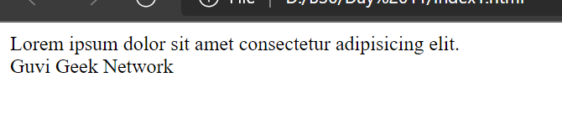

1. Try the below one

<html lang="en">

<head>

<title>Document

<body>

guvi

</head>

<div>

Lorem ipsum dolor sit amet consectetur adipisicing elit.

<div>

<div>

Guvi Geek Network

</div>

</body>

</html>

**Ans:**

**<html lang="en">**

**<head>**

**<title>Document guvi </title>**

**</head>**

**<body>**

**<div>**

**Lorem ipsum dolor sit amet consectetur adipisicing elit.**

**<div>**

**<div>**

**Guvi Geek Network**

**</div>**

**</div>**

**</div>**

**</body>**

**</html>**

OUTPUT:



1. Design a contact us form with all fields as required.

**Ans:**

<!DOCTYPE html>

<html>

    <head>

        <title>Contact Us</title>

    </head>

<body>

<h2>Contact Us</h2>

<form>

  <label for="name">Name:</label><br>

  <input type="text" id="name" name="name" placeholder="Name.."><br>

  <label for="email">Email:</label><br>

  <input type="text" id="email" name="email" placeholder="Email address.."><br>

  <label for="phone">Phone:</label><br>

  <input type="text" id="phone" name="phone" placeholder="Phone number.."><br>

  <label for="message">message</label><br>

  <textarea id="message" name="message" rows="4" cols="50" placeholder="enter a message..">

</textarea><br>

<button type ="submit">Send</button>

</form>

</body>

</html>

OUTPUT:

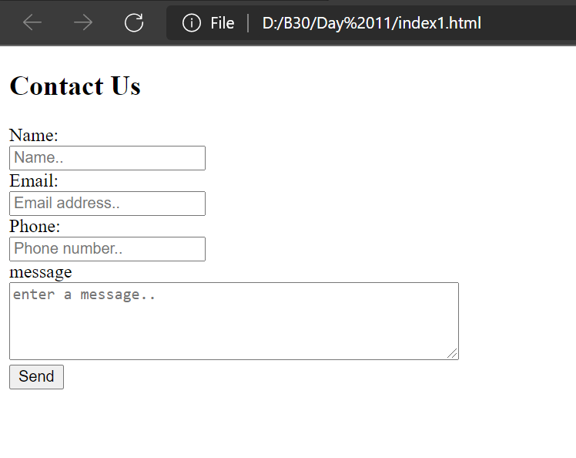

1. Use certain HTML elements to display the following in a HTML page.

* Programming Language
  + JavaScript
    1. Angular
    2. React
    3. Vue.js
  + Python
    1. Django Framework
    2. Flask Framework
  + Java
    1. Spring
    2. Maven
    3. Hibernate
* Database
  + MySQL
  + MongoDB
  + Cansandra

**Ans:**

<!DOCTYPE html>

<html>

<head>

    <title>Technologies</title>

</head>

<body>

    <h2> Technologies </h2>

    <ul>

        <li>

            <ul>Programming Language

                <li>JavaScript

                    <ol>

                        <li>Angular</li>

                        <li>React</li>

                        <li>Vue.js</li>

                    </ol>

                </li>

                <li>Python

                    <ol>

                        <li>Django Framework</li>

                        <li>Flask Framework</li>

                    </ol>

                </li>

                <li>Java

                    <ol>

                        <li>Spring</li>

                        <li>Maven</li>

                        <li>Hibernate</li>

                    </ol>

                </li>

            </ul>

        </li>

        <li>

            <ul>Database

                <li>MySQL</li>

                <li>MongoDB</li>

                <li>Cansandra</li>

            </ul>

        </li>

    </ul>

</body>

</html>

OUTPUT:

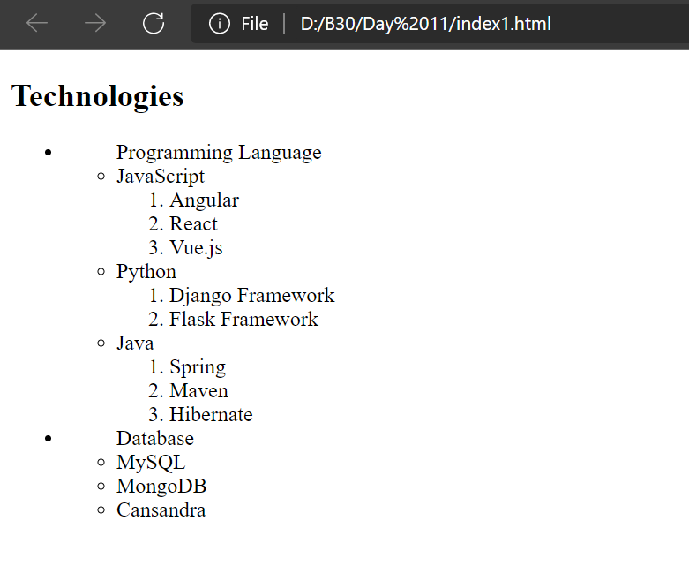

1. Create an element that helps you to open the <https://google.com> in separate new tab.

**Ans:**

<!DOCTYPE html>

<html>

<head>

    <title>route</title>

</head>

<body>

    <h2> Link Route </h2>

    <h4><a href="https://google.com" target="_blank"> Google</a></h4>

</body>

</html>

OUTPUT:

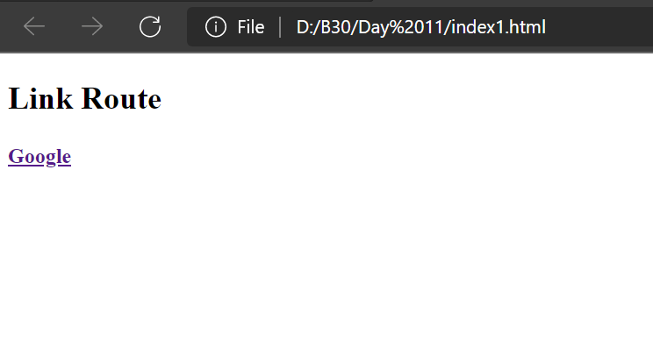

1. In the form, add two radio buttons with grouping them for employee type(Salaried and own business)

Ans:

<!DOCTYPE html>

<html>

<head>

    <title>Employee Data</title>

</head>

<body>

    <h2> Employee Data </h2>

    <form>

    <fieldset id="Employee">

        <h4> Employment type: </h4>

        <input type="radio" value="Salaried" name="Employee">

          <label for="Salaried">Salaried</label><br>

        <input type="radio" value="business" name="Employee">

          <label for="business">Own business</label><br>

    </fieldset>

    </form>

</body>

</html>

OUTPUT:

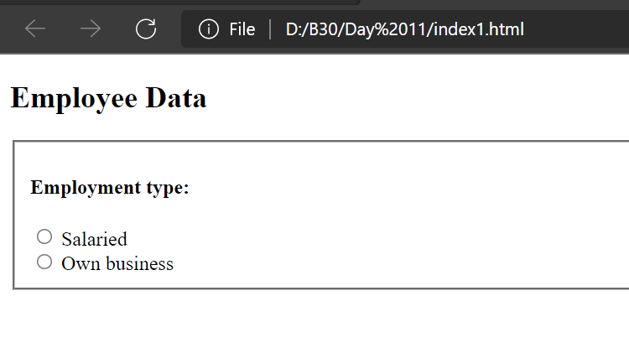

1. Design form shown in the link (<http://evc-cit.info/cit040/formguide/card_0.png>)

Ans:

<!DOCTYPE html>

<html>

<head>

    <title>Employee Data</title>

    <style>

        h2 {

            background-color: red;

            color: white;

            width: 40vw;

            text-align: center;

        }

        input {

            border: none;

            border-bottom: 2px solid black;

        }

        label {

            display: inline-block;

        }

        .main-div {

            border: 2px solid black;

            width: 45vw;

            height: 35vw;

            padding: 1vw;

        }

    </style>

</head>

<body>

    <div class="main-div">

        <h2> Yes! I want to subscribe to Mag-O-Zine</h2>

        <form>

            <label for="fname" style="width: 20vw;"> <input type="text" id="fname" name="fname"

                    placeholder="First name.." style="width: 20vw;">FirstName</label>&nbsp;&nbsp;

            <label for="lname" style="width: 20vw;"><input type="text" id="lname" name="lname" placeholder="Last name.."

                    style="width: 20vw;">LastName</label><br /><br />

            <label for="address" style="width: 41vw;"><input type="text" id="address" name="address"

                    placeholder="Address.." style="width: 41vw;">Address</label><br /><br />

            <label for="city" style="width: 13vw;"><input type="text" id="city" name="city" placeholder="City.."

                    style="width: 13vw;">City</label>&nbsp;&nbsp;

            <label for="state" style="width: 13vw;"><input type="text" id="state" name="state" placeholder="State.."

                    style="width: 13vw;">State</label>&nbsp;&nbsp;

            <label for="zip" style="width: 13vw;"><input type="text" id="zip" name="zip" placeholder="Zip.."

                    style="width: 13vw;">Zip</label><br />

            <h4> Subscribe for: </h4>

            <input type="checkbox" id="1yr" name="1yr" value="1year">

            <label for="1year"> 1 year ($19.95)</label>

            <input type="checkbox" id="2yr" name="2yr" value="2year">

            <label for="2year"> 2 year ($35.00)</label><br>

            <h4> Send me more information about: </h4>

            <input type="checkbox" id="cz" name="cz" value="cz">

            <label for="cz">Computer-Zone</label><br>

            <input type="checkbox" id="fz" name="fz" value="fz">

            <label for="fz">Fishing-Zone</label><br>

            <input type="checkbox" id="coz" name="coz" value="coz">

            <label for="coz">Cat-O-Zone</label>

        </form>

    </div>

</body>

</html>

OUTPUT:

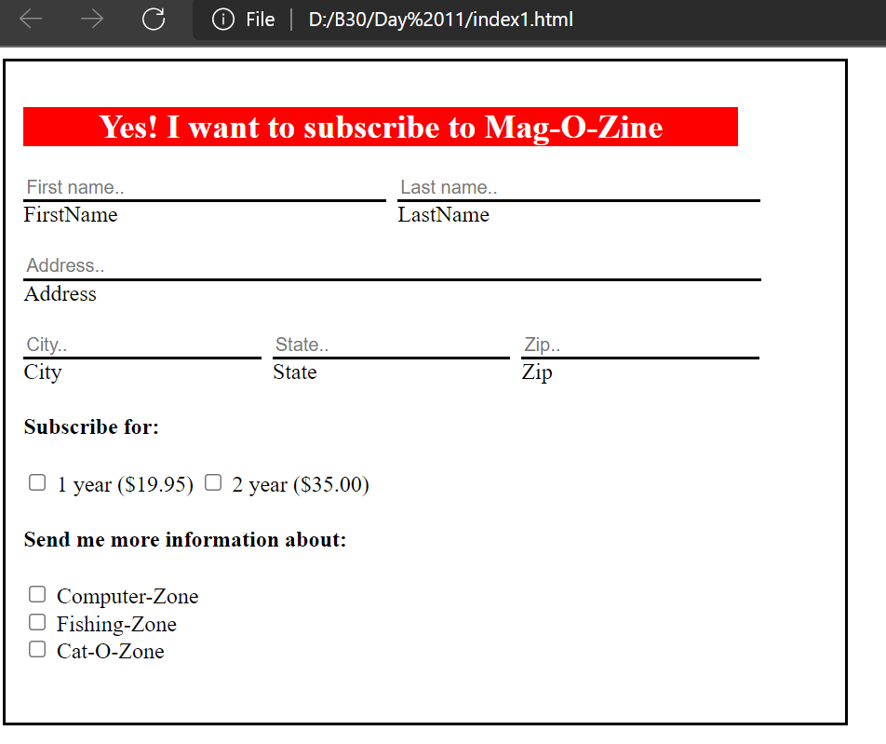

1. Use the table tag to design given image [Click here](https://www.bapugraphics.com/assets/img/port_upload_dir/table-4.jpg).

<!DOCTYPE html>

<html>

<head>

    <title>Chart</title>

    <style>

        table,

        th,

        td {

            border: 1px solid black;

            border-collapse: collapse;

        }

    </style>

</head>

<body>

    <h2>Health Chart</h2>

    <table>

        <tr>

            <th rowspan="2">State of Health</th>

            <th colspan="2">Fasting Value</th>

            <th>After Eating</th>

        </tr>

        <tr>

            <th>Minimum</th>

            <th>Maximum</th>

            <th>2 hours after eating</th>

        </tr>

        <tr>

            <th>Healthy</th>

            <td>70</td>

            <td>100</td>

            <td>Less than 140</td>

        </tr>

        <tr>

            <th>Pre-Diabetes</th>

            <td>101</td>

            <td>126</td>

            <td>140 to 200</td>

        </tr>

        <tr>

            <th>Diabetes</th>

            <td>More than 126</td>

            <td>N/A</td>

            <td>More than 200</td>

        </tr>

    </table>

</body>

</html>

OUTPUT:

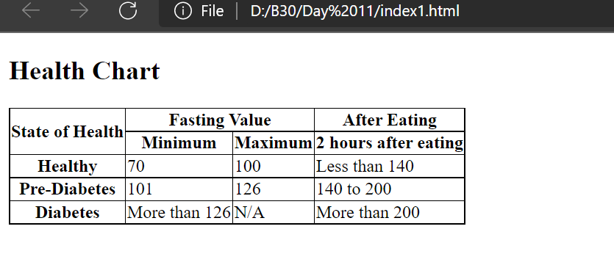

1. Write HTML input tags snippet to show default values for all Form elements.

<!DOCTYPE html>

<html>

<head>

    <title>inputs</title>

</head>

<body>

    <h2>Input types</h2>

    <form>

        <table>

            <tr>

                <td> <label for="chk">Checkbox input</label></td>

                <td> <input type="checkbox" id="chk" value="chk" name="chk" checked></td>

            </tr>

            <tr>

                <td><label for="favcolor">Color input</label></td>

                <td><input type="color" id="favcolor" name="favcolor" value="#f6b73c"></td>

            </tr>

            <tr>

                <td><label for="date">Date input</label></td>

                <td><input type="date" id="date" name="date" value="2018-07-22"></td>

            </tr>

            <tr>

                <td><label for="dt">Date Time input</label></td>

                <td><input type="datetime-local" id="dt" name="dt" value="2018-06-12T19:30"></td>

            </tr>

            <tr>

                <td> <label for="email">Email input</label></td>

                <td><input type="email" id="email" name="email" value="example@abc.com"></td>

            </tr>

            <tr>

                <td><label for="month">Month input</label></td>

                <td><input type="month" id="month" name="month" value="2018-05"></td>

            </tr>

            <tr>

                <td> <label for="number">Number input</label></td>

                <td><input type="number" id="number" name="number" value=123></td>

            </tr>

            <tr>

                <td> <label for="password">Password input</label></td>

                <td><input type="password" id="password" name="password" value="abc"></td>

            </tr>

            <tr>

                <td><label for="radio">Radio input</label></td>

                <td><input type="radio" id="radio" name="radio" checked></td>

            </tr>

            <tr>

                <td><label for="range">Range input</label></td>

                <td><input type="range" id="range" name="range" value=10></td>

            </tr>

            <tr>

                <td> <label for="search">Search input</label></td>

                <td><input type="search" id="search" name="search" value="html"></td>

            </tr>

            <tr>

                <td><label for="tel">telephone number input</label></td>

                <td><input type="tel" id="tel" name="tel" value=123456778></td>

            </tr>

            <tr>

                <td> <label for="text">Text input</label></td>

                <td><input type="text" id="text" name="text" value="default val"></td>

            </tr>

            <tr>

                <td> <label for="time">Time input</label></td>

                <td><input type="time" id="time" name="time" value="18:00"></td>

            </tr>

            <tr>

                <td><label for="url">URL input</label></td>

                <td><input type="url" id="url" name="url" value="https://example.com"></td>

            </tr>

            <tr>

                <td><label for="week">Week input</label></td>

                <td><input type="week" id="week" name="week" value="2018-W26"></td>

            </tr>

        </table>

    </form>

</body>

</html>

OUTPUT:

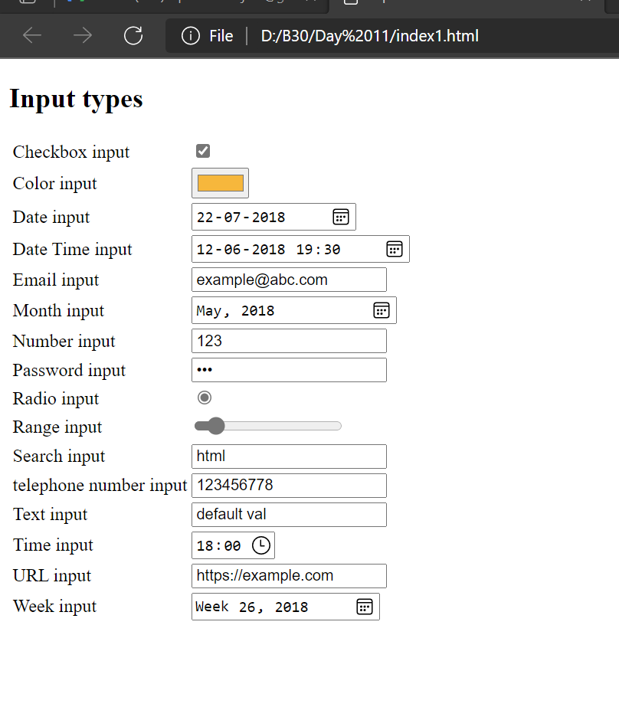

1. In your, HTML page add the below line and Highlight it without using any CSS.

* "HTML & CSS is awesome"

<!DOCTYPE html>

<html>

<head>

    <title>Highlight</title>

</head>

<body>

    <h2>Highlight</h2>

    <mark>HTML & CSS is awesome</mark></p>

</body>

</html>

OUTPUT:

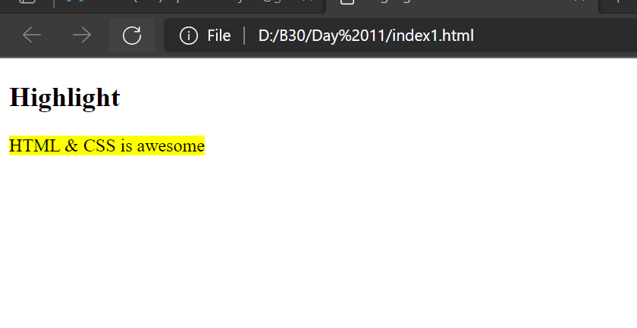

1. Create an HTML page, which should contain all types of input elements.

<!DOCTYPE html>

<html>

<head>

    <title>inputs</title>

</head>

<body>

    <h2>Input types</h2>

    <form>

        <table>

            <tr>

                <td><label for="button">Button input</label></td>

                <td><input type="button" value="button" id="button" name="button"></td>

            </tr>

            <tr>

                <td> <label for="chk">Checkbox input</label></td>

                <td> <input type="checkbox" id="chk" value="chk" name="chk"></td>

            </tr>

            <tr>

                <td><label for="favcolor">Color input</label></td>

                <td><input type="color" id="favcolor" name="favcolor"></td>

            </tr>

            <tr>

                <td><label for="date">Date input</label></td>

                <td><input type="date" id="date" name="date"></td>

            </tr>

            <tr>

                <td><label for="dt">Date Time input</label></td>

                <td><input type="datetime-local" id="dt" name="dt"></td>

            </tr>

            <tr>

                <td> <label for="email">Email input</label></td>

                <td><input type="email" id="email" name="email"></td>

            </tr>

            <tr>

                <td> <label for="file">File input</label></td>

                <td> <input type="file" id="file" name="file"></td>

            </tr>

            <tr>

                <td><label for="month">Month input</label></td>

                <td><input type="month" id="month" name="month"></td>

            </tr>

            <tr>

                <td> <label for="number">Number input</label></td>

                <td><input type="number" id="number" name="number"></td>

            </tr>

            <tr>

                <td> <label for="password">Password input</label></td>

                <td><input type="password" id="password" name="password"></td>

            </tr>

            <tr>

                <td><label for="radio">Radio input</label></td>

                <td><input type="radio" id="radio" name="radio"></td>

            </tr>

            <tr>

                <td><label for="range">Range input</label></td>

                <td><input type="range" id="range" name="range"></td>

            </tr>

            <tr>

                <td> <label for="reset">Reset input</label></td>

                <td><input type="reset" id="reset" name="reset"></td>

            </tr>

            <tr>

                <td> <label for="search">Search input</label></td>

                <td><input type="search" id="search" name="search"></td>

            </tr>

            <tr>

                <td><label for="submit">Submit input</label></td>

                <td><input type="submit" id="submit" name="submit"></td>

            </tr>

            <tr>

                <td><label for="tel">telephone number input</label></td>

                <td><input type="tel" id="tel" name="tel"></td>

            </tr>

            <tr>

                <td> <label for="text">Text input</label></td>

                <td><input type="text" id="text" name="text"></td>

            </tr>

            <tr>

                <td> <label for="time">Time input</label></td>

                <td><input type="time" id="time" name="time"></td>

            </tr>

            <tr>

                <td><label for="url">URL input</label></td>

                <td><input type="url" id="url" name="url"></td>

            </tr>

            <tr>

                <td><label for="week">Week input</label></td>

                <td><input type="week" id="week" name="week"></td>

            </tr>

        </table>

    </form>

</body>

</html>

OUTPUT:

